|  |  |  |
| --- | --- | --- |
| **C++ Programming** | **Student**  **number** | **21300691** |
| **Homework 1** | **Name** | **Cheung, Won Sik** |

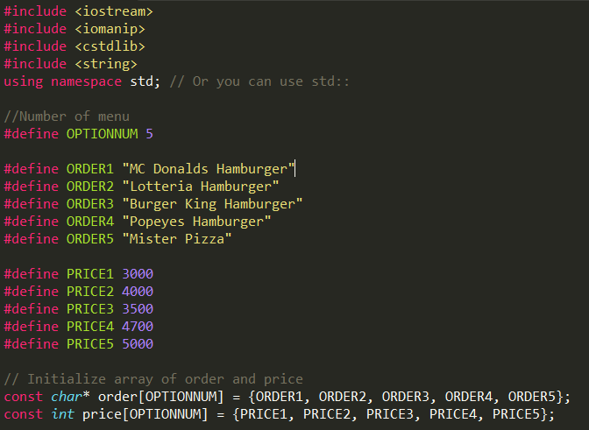

Header file, macro variable and constant.

cstdlib for built in function itoa() that make integer to string.

I define order and price by using #define because we didn’t study structure in cpp. By using define macro, it was easy to insert order and price.

And insert them to const array.

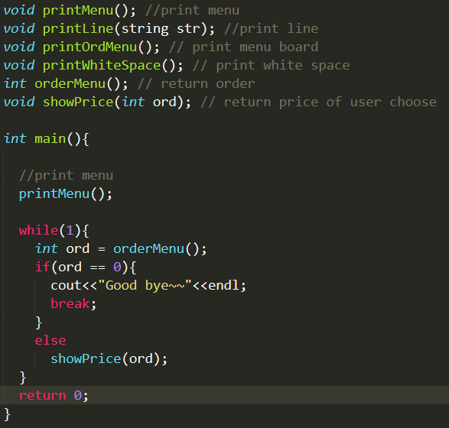

There are 6 function I used.

Main function firstly shows menu board using prinMenu function.

Second, get order from users. If order is 0, print goodbye. If order is menu number than show price and take order again.

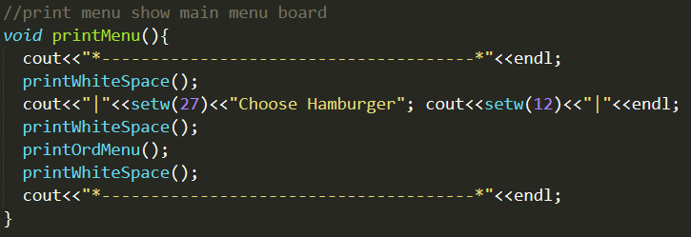

Print menu function show main menu board.

And it use printWhiteSpace, printOrdMenu.

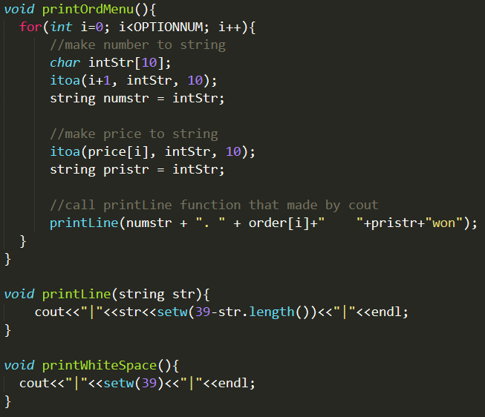

PrintOrdMenu show menu board and use itoa function to number to string.

And it uses printLine function which use cout, print order and price.

PrintWhiteSpace function print white space to make gap in menu.

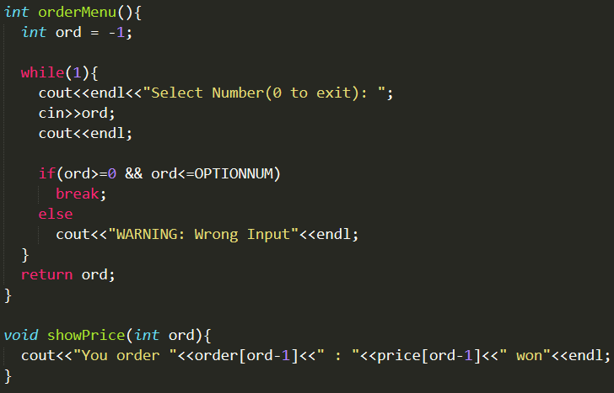

OrderMenu function get order from user and check is this valid. Finally it returns order.

ShowPrice function print user’s order and it’s price.

result

